BIOMOLECULES and THE LABEL WE SHOULD BE READING

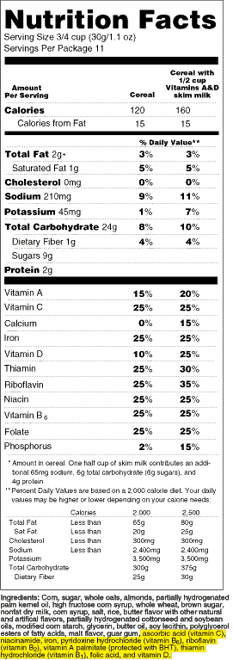
Biomolecules: The molecules of life. Three of the four
biomolecules required for living beings must be consumed
through food. To ensure to are receiving the correct amount
of each molecule, food labels include the provide the
information for you. You just have to know how to read it.

1.You must consume which of the 4 biomolecules through
food? ________________________________________
_____________________________________________
_____________________________________________
2. What unit of measurement is used to measure the
biomolecules on this label?
3. Circle the number of carbohydrates on this label and
write the amount here: ________________
3. Put a box around the amount of proteins on this label
and write it here _____________________
4. Tricky….Underline and write down the number of lipids
on this label and write it here ______________________

Now it’s your turn…turn the page over

- What is your food or drink product? _________________________________________
- Complete the Food Label by putting your food or drink item’s information onto the label below. Then answer the questions below.
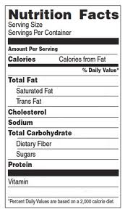

Circle the number of carbohydrates on this label and write the amount here: _______________
Put a box around the amount of proteins on this label and write it here _____________________
Underline and write down the number of lipids on this label and write it here ______________________

