Cell Transport

The main function of the cell membrane is to help us maintain homeostasis. The cell membrane accomplishes this by regulating what enters and leaves the cell. There are 2 main types of cell transport: passive and active.

Passive transport
Passive transport requires no energy. Molecules simply pass through the membrane along their concentration gradient (from an area of high concentration to low concentration).
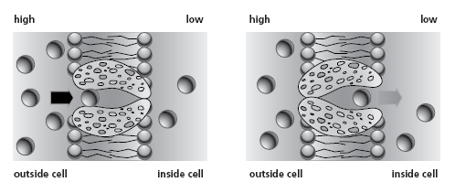
- Diffusion- a type of passive transport in which small molecules such as oxygen, carbon dioxide and hormones move across the membrane from a high concentration to a low concentration.
- Osmosis- a type of passive transport in which water moves across the membrane from a high concentration to a low concentration.
- Facilitated diffusion- a type of passive transport in which ions(K+, Cl-, Na+) and glucose pass through a protein channel in the membrane from an area of high concentration to an area of low concentration.
- Receptor mediated endocytosis – a type of active transport in which proteins and cholesterol bind to receptors on the plasma membrane and are taken into the cell via vesicle. Movement occurs against their concentration gradients (from low to high).
- Phagocytosis – a type of active transport in which large particles are taken into the cell against their concentration gradient. This process is also known as “cell eating”.
- Pinocytosis- a type of active transport in which liquid molecules are taken into the cell against their concentration gradient. This process is also known as “cell drinking”.
- Protein Pump- a type of active transport in which ions (K+, Cl-, Na+), protons (H+) and other molecules/compounds are pumped across the cell by a protein. These molecules are transferred from an area of low concentration to an area of high concentration.
- Exocytosis- a type of active transport in which waste and hormones are excreted from the cell against their concentration gradient.
Active transport
Active transport requires energy. Molecules need energy to move against their concentration gradients (from an area of low concentration to an area of high concentration).
