Evolution Review

Define evolution: a change over time
Give an example of something not found in nature that has evolved:
Cell Phone or TV
Who is the father of evolution?
Charles Darwin
State his 4 postulates
Individuals in a population differ from one another. (Diversity or Variation)
Some differences are due to characteristics that are passed down from parent to child. (Inherited variation)

More offspring are produced than can survive, so some will survive and reproduce and others will not.

Survival and reproduction depend on advantageous traits.
Explain “survival of the fittest”
- Natural Selection is also known as “survival of the fittest” meaning that the most fit organism in the environment will survive .
- Fitness refers to an organisms ability to survive and reproduce.

Give an example of artificial selection
Man choosing to genetically alter watermelon to make seedless watermelon or choosing which 2 dogs to breed

Define gene pool: The total number of alleles in a population

Can an individual organism change its own genes?
No, genes change over generation and throughout an entire population
If two organisms share 95% of the same DNA sequence, what does this show?
A genetic relationship and possible common ancestor
What is a vestigial structure/organ? Give an example.
A structure or organ that the organism no longer uses but shows that the organism may have one needed it…the organism evolved and no longer needs to structure. Whale femur and human tail bone

What is the difference in Homologus structure and Analogous structure?
Homo is the similar structure showing common ancestor, Ana is similar function but no evidence of common ancestor
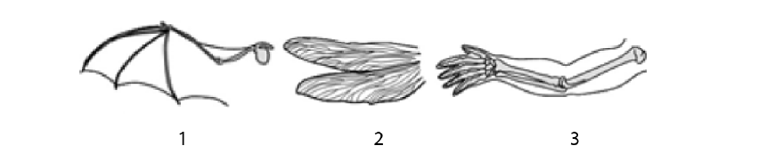

Figure 1 & 2 are what type of structure?
HOMOLOGOUS
Figure 1 & 3 are what type of structure?
Analogous

State and define 3 types of isolation….include examples.
- Behavioral Isolationwhen two populations are capable of interbreeding but have differences in courtship rituals or other reproductive strategies that involve behavior.
- Geographic Isolation when two populations are separated by geographic barriers such as rivers or mountains.
- Temporal Isolation when two or more species reproduce at different times.

What is another term for gene flow?
Migration

What 2 terms can cause Genetic Drift?
Founder Effect & Bottle Neck

