Final Review
1st Six Weeks Review
- What is the difference between prokaryotic and eukaryotic cells?
Pro- no nucleus Eu- nucleus and complex
- What are the 3 parts of the cell theory?
1. All living things are composed of cells.
2. Cells are the basic unit of structure and function.
3. All cells are produced from other cells.
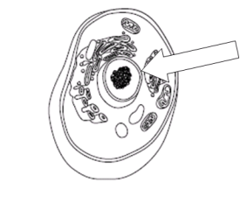
- What part of the cell is identified with the arrow? nucleus

- What structures is common to ALL cells? Cell membrane
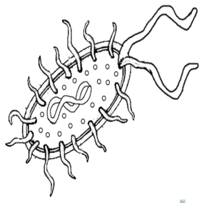
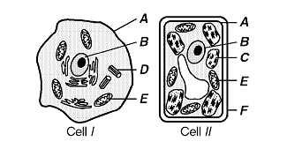
- Label the following cells prokaryote or eukaryote.

Eu Eu Pro
- What are the 2 types of virus cycles? Lytic and Lysogenic
- What are the similarities between a cell and virus?all the nucleic acids
- List the 6 Kingdoms.
fungi, plantae archeabacteria eubacteria protista
- Which kingdom contains eukaryotic heterotrophs with cell walls made of chitin? fungi
2nd Six Weeks Review
- What are the 4 macromolecules found in the body?
- Carbohydrates:
a. Function: provide energy
b. Elements: CHO
c. Monomer: saccharide
d. Polymer: carbohydrate
e. Structure: rings
f. Example: pasta, bread
- Lipid:
a. Function: storage of energy
b. Elements: C,H,O
c. Monomer: glycerol
d. Polymer: lipid
e. Structure: long chains or lines
f. Example: fats, waxes
- Protein
a. Function: : repairs and builds muscle. Controls rate of action, and metobolism
b. Elements: CHON
c. Monomer: amino acides
d. Polymer: protein
e. Structure: make of CHONP
f. Example: muscle, enzyme
- Nucleic Acid:
a. Function:
b. Elements: C H O N P
c. Monomer: nucleotide
d. Polymer: RNA
e. Structure: phosphate, base and sugar
f. Example: DNA ATP
- What is an enzyme? A protein that speeds up chemical reactions by lowering the activation energy
- What does the enzyme affect the reactions in living things by changing? Lowers energy
- In what conditions does an enzyme work best?
- Identify the following letter in the enzyme reaction.
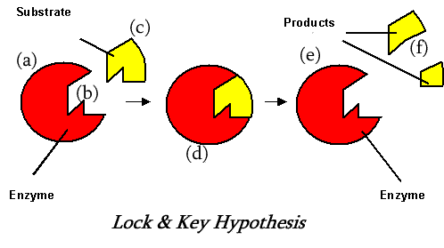
- Enzyme b. active site c. substrate d. enzyme-substrate complex e. enzyme f. product
c. reactant.
- What is passive transport? Molecules from hi conc to low conc and doesn’t require energy
- Describe the 3 types of passive transport. Diffusion, osmosis, facilicated diffision

- What is active transport? Molecules move from a low to high concentration
- Describe the 3 type of active transport. Protein pumps, exocytosis endocytosis
- What type of transport is the following diagram demonstrating? Active transport
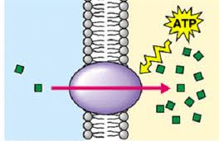
3rd Six Weeks Review
- What does the acronym DNA stand for? Deoxyribonucleic acid
- What is the monomer of DNA? nucleotide
- What are the components that make up a nucleotide in DNA? Phosphate sugar and nitrogen base
- What the bases of DNA? A T C G
- What is the function of DNA? BLUE PRINT OF LIFE
- What is the difference between DNA and RNA
REPLICATION
- List the steps of DNA replication.
- What is the final product of DNA replication? 2 identical strands of DNA
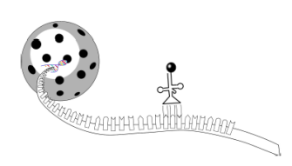
- What is the process illustrated in the following diagram? Protein synthesis

- What is produced during transcription? mRNA
- What determines the traits of an organism in DNA? Sequence of nitrogen bases in DNA
- What process is illustrated in the following diagram? Cellular Respirations
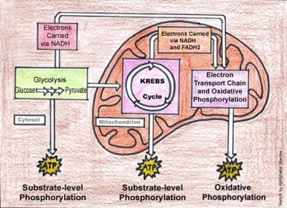
- What organelle does this process occur in the cell? mitochondria
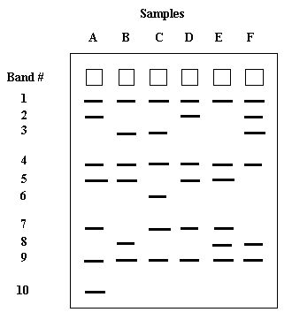
- Use the diagram below to tell me which sample is the same person? None are a match

- What type of mutation is the following mutation? SUBSTUTION
Original: ACTACTACTGGGAGT
Mutated: ACTACTACTGGAAGT
- List and describe the 2 types of gene mutations.
Point and frameshift

