Final Review
1st Six Weeks Review
- What is the difference between prokaryotic and eukaryotic cells?
- What are the 3 parts of the cell theory?
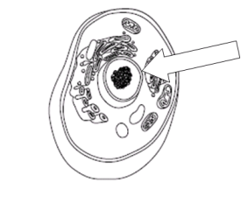
- What part of the cell is identified with the arrow?

- What structures is common to ALL cells?
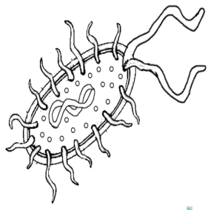
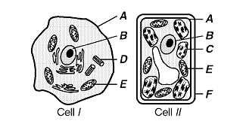
- Label the following cells prokaryote or eukaryote.

- What are the 2 types of virus cycles?
- What are the similarities between a cell and virus?
- List the 6 Kingdoms.
- Which kingdom contains eukaryotic heterotrophs with cell walls made of chitin?
2nd Six Weeks Review
- What are the 4 macromolecules found in the body?
- Carbohydrates:
a. Function:
b. Elements:
c. Monomer:
d. Polymer:
e. Structure:
f. Example:
- Lipid:
a. Function:
b. Elements:
c. Monomer:
d. Polymer:
e. Structure:
f. Example:
- Protein:
a. Function:
b. Elements:
c. Monomer:
d. Polymer:
e. Structure:
f. Example:
- Nucleic Acid:
a. Function:
b. Elements:
c. Monomer:
d. Polymer:
e. Structure:
f. Example:
- What is an enzyme?
- What does the enzyme affect the reactions in living things by changing?
- In what conditions does an enzyme work best?
- Identify the following letter in the enzyme reaction.
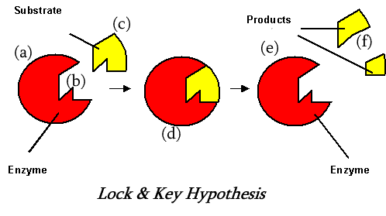
- What is passive transport?
- Describe the 3 types of passive transport.
- What is active transport?
- Describe the 3 type of active transport.
- What type of transport is the following diagram demonstrating?
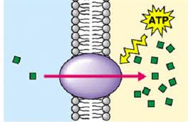
3rd Six Weeks Review
- What does the acronym DNA stand for?
- What is the monomer of DNA?
- What are the components that make up a nucleotide in DNA?
- What the bases of DNA?
- What is the function of DNA?
- What is the difference between DNA and RNA
- List the steps of DNA replication.
- What is the final product of DNA replication?
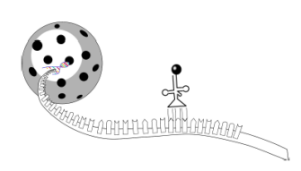
- What is the process illustrated in the following diagram?

- What is produced during transcription?
- What determines the traits of an organism in DNA?
- What process is illustrated in the following diagram?
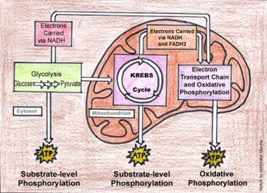
- What organelle does this process occur in the cell?
- Use the diagram below to tell me which sample is the same person?
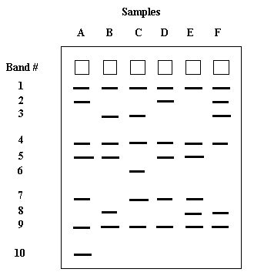

- What type of mutation is the following mutation?
Original: ACTACTACTGGGAGT
Mutated: ACTACTACTGGAAGT
- List and describe the 2 types of gene mutations.

