Notes – Speciation and Evolution
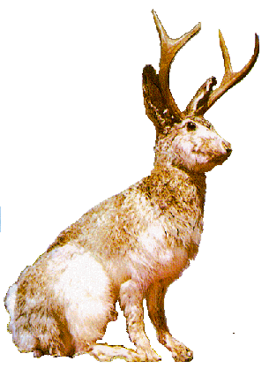
- Species Defined
  - Morphological Species Concept: the idea that organisms can be classified by differences in their _________________________.
  - Biological Species Concept: the idea that organisms can be classified by their ability to ____________________ with one another.
  - Scientists use both to define species.
- Species: A group of ________________________ that look similar and whose members are capable of producing __________________ offspring in the __________________ environment
- Variation within a population
  - __________________________: all the members of a species that live in the same area and make up a breeding group
  - Within a population, individuals ____________ in many observable traits.
- Natural Selection
  - _______________________________ is an ongoing process in nature, and is the single most significant factor disrupting genetic _________________________.
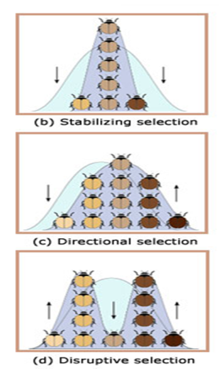
- 4 Types of Natural Selection

- Stabilizing Selection
  - Stabilizing Selection: ____________________ form of a trait is an advantage
  - The extreme forms ______________________
  - Stabilizing selection is the ______________________ type of NS.
- Directional Selection
  - Directional Selection: the distribution of a trait is shifted toward one of the _______________________.
- Disruptive Selection
  - Disruptive Selection: ________________________ of the extreme forms is advantage in terms of survival and reproduction
    - The average trait is a __________________________.
- Sexual Selection:
  - the preferential choice of a _______________ based on the presence of a specific trait
    - Sexual selection may be _________________, ____________________, or _______________________.
- Speciation
  - Speciation: the formation of a new _______________________.

- Isolated Populations
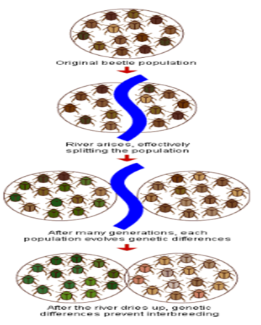
  - For speciation to occur populations must stop ______________________.
  - Three Forms of Reproductive Isolation:

- Geographic Isolation:
  - Physical separation of populations
    - Examples: population becomes ___________________by land or water barrier, colonization of new island, river changes course, highway built across field, etc.
  - Also called ___________________ speciation.
- Speciation Causes Diversity
  - _________________________ or biological diversity is the sum total of the variety of all the organisms in the biosphere
    - ___________________________ - process in which a single species evolves into several different forms that live in different ways
    - ___________________________ - process in which unrelated organisms evolve to resemble one another
- Adaptive Radiation
  - _____________________________ can occur when an organism occupies a new environment with unoccupied niches.
  - The colonizing population may diversify rapidly to take advantage of all possible _____________.
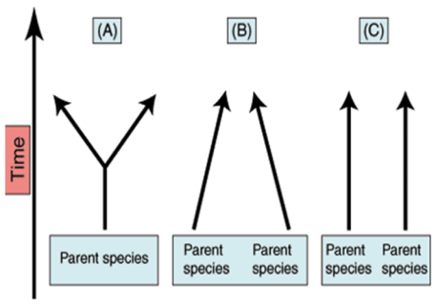
  - Adaptive radiation can cause:
    - ________________________ (a)common ancestor trait changes over time with different species
    - ________________________________ (b) occurs when similar environments cause species to resemble each other
    - ___________________________ (c) occurs with closely connected organisms that evolve together

- Reproductive Isolation
  - Inability of formerly _______________________ organisms to produce offspring.
- Rates of Speciation
  - ___________________________: brief periods of rapid genetic change
  - ________________________: gradual change of adaptations
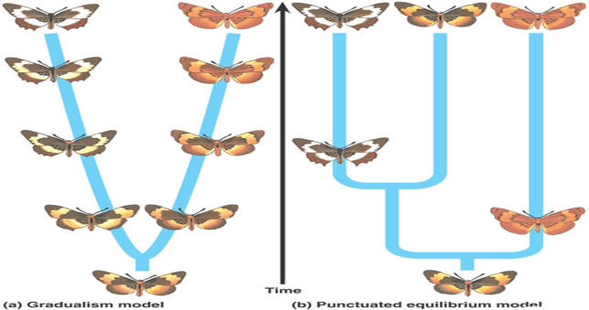
  - ___________________: the state of a species that no longer exists
    - For a species to continue to exist, some members must have ____________that allow them to _______________ and pass their genes on to the next _________________

