lPhotosynthesis Floating Leaf Lab
Reference textbook for assistance page 213.
Download iNigma. Scan the QR code with your smartphone. Watch the video and answer the following questions.
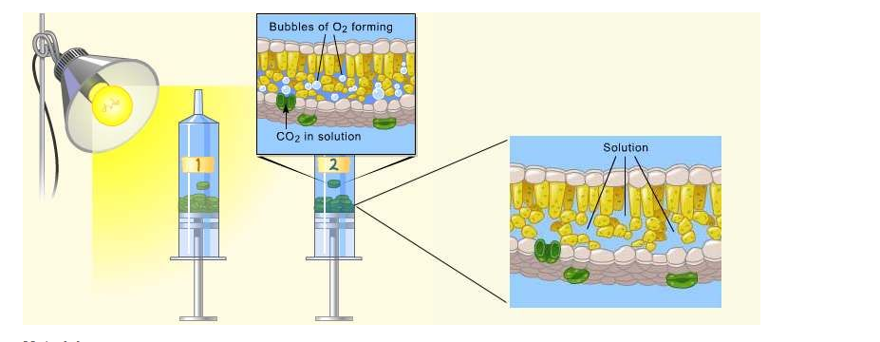
- Write the equation of photosynthesis.

- What is your hypothesis? If a ____________ is expose to sunlight, then it will ______________ the rate of photosynthesis.

- What was the function of the sodium bicarbonate(baking soda)?

- Graph your data(use a line graph)from the information in the chart.
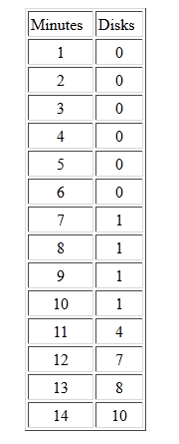
Title: ______________________________________________________________

- Explain the process of carbon fixation?

- Explain the process that causes the leaf disks to rise?

- What is the effect of darkness on photosynthesis? Explain

- If we were to boil the leaf disk, what kind of results would you expect? Explain

- How does light intensity affect the rate of photosynthesis?

- How does light intensity and the rate of photosynthesis relate to the position of the sun, both during the day and during the year?

