Photosynthesis Notes
- Energy needs of life
  - All life needs a constant input of energy
    - _____________________________(Animals)
      - get their energy from “eating others”
        - eat food = other organisms = ___________________________
      - make energy through ___________________________
    - _______________________________(Plants)
      - get their energy from “self”
      - get their energy from sunlight
      - build _______________________________________ (food) from CO₂
      - make energy & synthesize sugars through ________________________
  - Heterotrophs
    - ___________________________
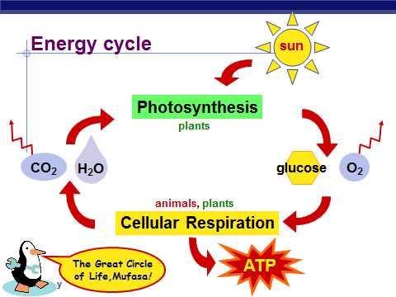
      - animals
      - fungi
      - most bacteria
    - Autotrophs
      - ________________________
      - plants
      - photosynthetic bacteria
(blue-green algae)
      - chemosynthetic organisms
- How are they connected?
  - Heterotrophs
    - glucose + oxygen → carbon dioxide + water + energy
    - ____________________________________________
    - Carbon dioxide and water yields glucose and oxygen
    - ____________________________________________
- What does it mean to be a plant?
  - Need to…
    - collect ____________________ energy
      - transform it into _____________________ energy
    - store light energy
      - in a stable form to be moved around
the plant & also saved for a rainy day
    - need to get ____________________________________
from the environment
      - C,H,O,N,P,K,S,Mg
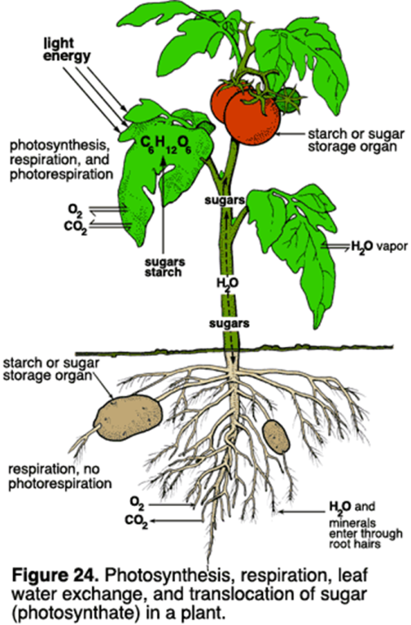
  - produce all _____________________________
needed for growth
    - carbohydrates, proteins, lipids, nucleic acids

- Plant structure – Structure is related to function!!!!!!
  - Obtaining raw materials
    - ________________________
      - _______________ = solar collectors
    - _________
      - ________________ gas exchange
    - ________
      - uptake from _______________
    - ____________________
      - N, P, K, S, Mg, Fe…
      - uptake from roots

  - Chloroplasts
    - double membrane
    - __________________________
      - fluid-filled interior
    - __________________________
      - __________________________
    - Thylakoid membrane contains
      - chlorophyll molecules
      - electron transport chain
      - ATP synthase
        - H⁺ gradient built up within thylakoid sac
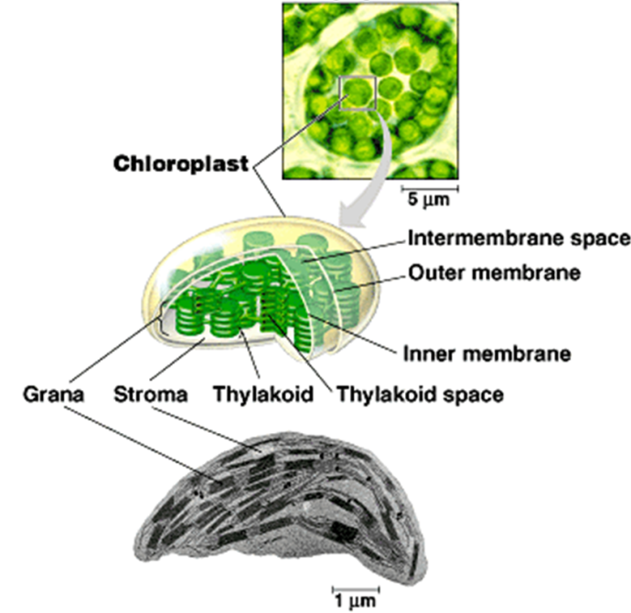

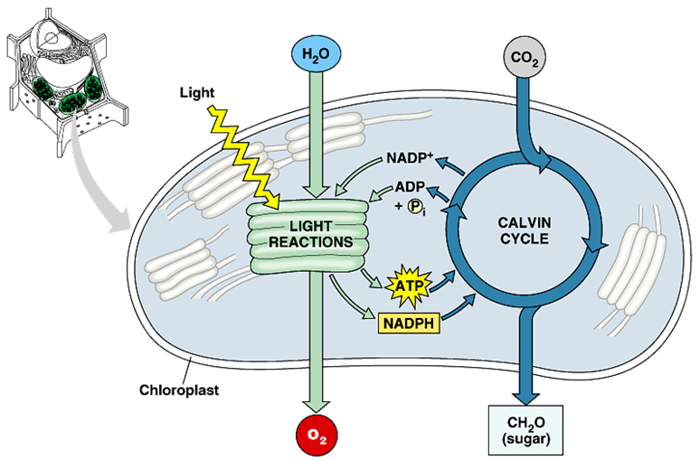
- Photosynthesis
  - _________________________________
    - Light-dependent reactions
    - energy production reactions
      - convert solar energy to chemical energy
      - ATP & NADPH
  - _________________________________
    - light-independent reactions
    - sugar production reactions
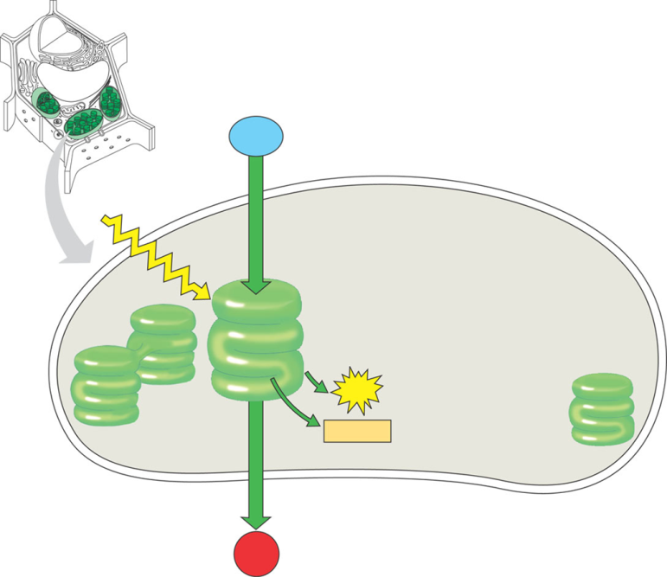
      - uses chemical energy (ATP & NADPH) to reduce CO₂ & synthesize C₆H₁₂O₆
- Light Reactions
  - produces ATP
  - produces NADPH
  - releases O₂ as a waste product

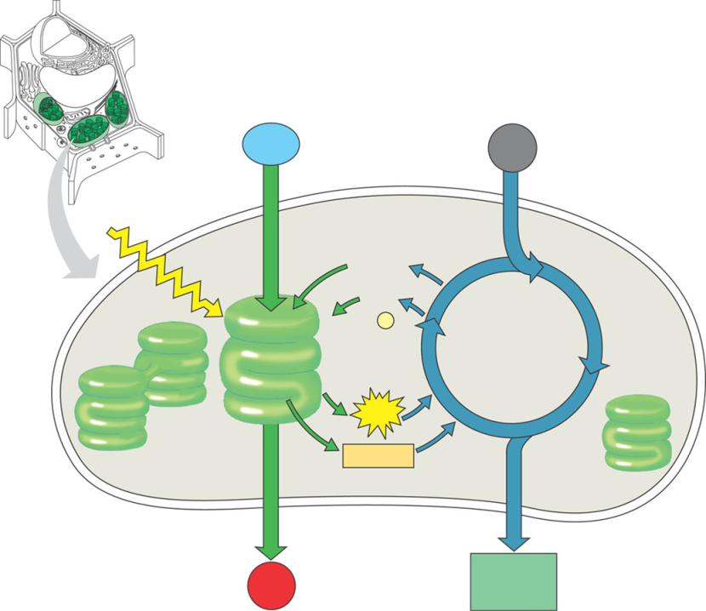
- Calvin Cycle
  - builds sugars
  - uses ATP & NADPH
  - recycles ADP & NADP back to make more ATP & NADPH

