Name:________________________________
TEST REVIEW:
Cell Cycle, Mitosis, Meiosis, Karyotypes, and Genetics

- What is the Cell cycle? A series of events a cell goes through as they grow and divide
- What are the phases of the cell cycle?
1.G1
2.S
3.G2
4.M
- What happens in each of the cell cycle phases?
1.G1 – cell does most of its growing
2.S - Chromosomes are replicated
3. G2 organeels required for division are produced
4. M – cellular division
- Draw a diagram representing the cell cycle.
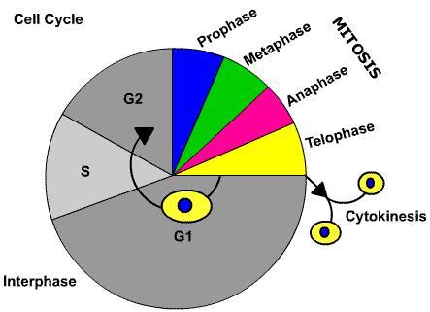

- What causes cancer? Mutations in the DNA
- What happens in Mitosis? One parent cell produced 2 identical cells with the SAME # of chromosomes as the parent cell
- How many cells are produced in Mitosis? 2
- What type of cells go through Mitosis? Somatic (body Cells)
- Are the cells Haploid or Diploid that go through Mitosis? Diploid
- What are the phases of Mitosis in order?
Prophase, metaphase, anaphase, telophase

- Draw and color Interphase
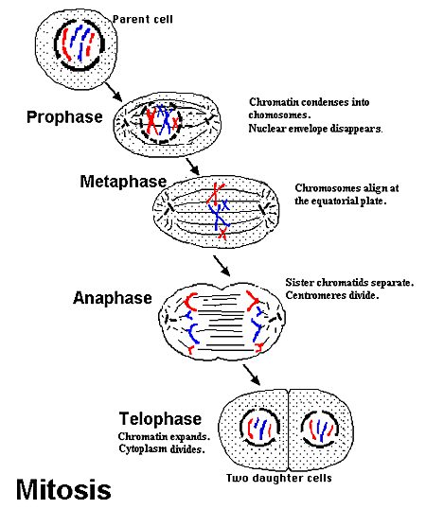

- Draw and color prophase.

- Draw and color metaphase.

- Draw and color Anaphase.

- Draw and color Telophase.

- Explain in words what happens in Interphase.
Cell grows and replicates DNA
- Explain in words what happens in prophase.
Chromosomes appear

- Explain in words what happens in metaphase.
Chromosomes line up in the middle of the cell

- Explain in words what happens in Anaphase.
Chromatids separate and move to opposite ends of the cell
- Explain in words what happens in Telophase.
2 new nuclear membranes form

- What in the last step in cell division?
cytokinesis

- What happens in Meiosis? A gamate cell is divide into 4 cells with ½ the number of chromsomes as the original cell
- How many cells are produced in Meiosis? 4
- What type of cells go through Meiosis? Sex cells…gametes
- Are the cells Haploid or Diploid that go through Meiosis? Division 1 Diploid, Division 2 Haploid
- What are the phases of Meiosis in order?
Prophase 1, metaphase 1, anaphase 1, telophase 1 & cytokinesis, prophase II, metaphase II, Anaphase II, Telophase II and cytokinesis

- What causes genetic variation/diversity in Meiosis? Crossing over
- Are all of your gametes identical? NO…all different
- What is a Karyotype? A picture of all of the chromosomes of a particular organism

- Analyze the karyotype below.
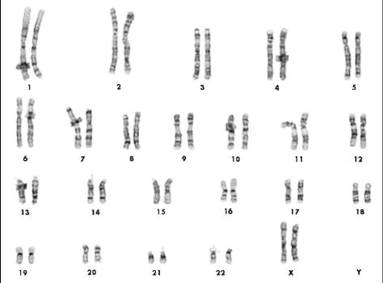
Is the Karyotype a human Karyotype? Yes, 23 pair
Is this of a male or female? female
Are they normal or mutated? normal

- Analyze the karyotype below.
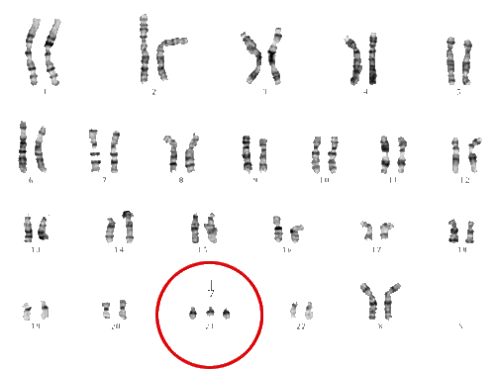
Is this karyotype a human karyotype? Yes, 23 pair
Is there a mutations? yes
If so what is the type of mutation? Trisomy 21
Is this a male or female? female

- How many chromosomes do you have in your somatic cells? 46
- How many chromosomes do you have in your gametes? 23
- Draw a picture of a chromosome.
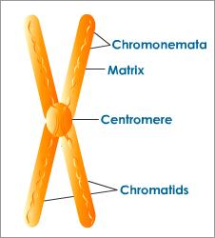

- 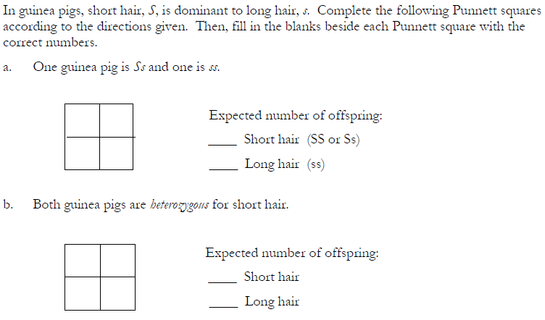

For each of the following problems, give the genotype of the parents, make a Punnett square and give the genotype ratio and phenotype ratio expected in the offspring.
- In hobbits, hairy toes (H) are dominant to smooth toes(h). Cross a homozygous hairy toed hobbit with a heterozygous hairy toed hobbit.

- Dihybrid cross
In summer squash, white fruit color (W) is dominant over yellow fruit color (w) and disk-shaped fruit (D) is dominant over sphere-shaped fruit (d). If a squash plant true-breeding for white, disk-shaped fruit is crossed with a plant true-breeding for yellow, sphere-shaped fruit, what will the phenotypic and genotypic ratios be for:

Parents Genotype_____________X______________

White / Disk shaped :
White/ Sphere shaped:
Yellow/ Disk shaped:
Yellow/ Sphere shaped:

Phenotypic Ratio: ______:______:_____:______

WwDd:
WWDD:
wwDd:
wwDD
wwdd:
Wwdd:
WWdd:
Genotypic Ratio:_____:_____:_____:______

Define the following terms:

Phenotype- physical appearance- blue eyes, curly hair

Genotype- genes , HH, Hh, hh

Homozygous Dominant - HH

Homozygous Recessive - hh

Heterozygous - Hh

Purebred- HH, hh

Hybrid- Hh

Allele- the letters,

Gene- the location on the chromosome where the alleles are located

